**COMP3421 Web Application Design and Development**

**Group Project : Deliverable 1 System Design Specification**

**Wu Hon Kiu 16075843d**

*Introduction*

The project website is to teach different algorithms about sorting. Three new functions are designed and implemented with the Model-View-Controller design pattern in order to increase the reusability of the code. These functions are Question-and-Answer section, Coding exercise and Leaderboards.

*Function Design*

All function have implemented Model-View-Controller design pattern. The dispatcher is included inside the web page, the model, view and controller folder are used to store it respectively. All function have their own MVC modules, and the name of those files are XXYYYY.php, where ‘XX’ can be ‘QA’, ‘C’E, ‘LB’ while the ‘YYYY’ can be ‘Model’, ‘View’ or ‘Controller’.

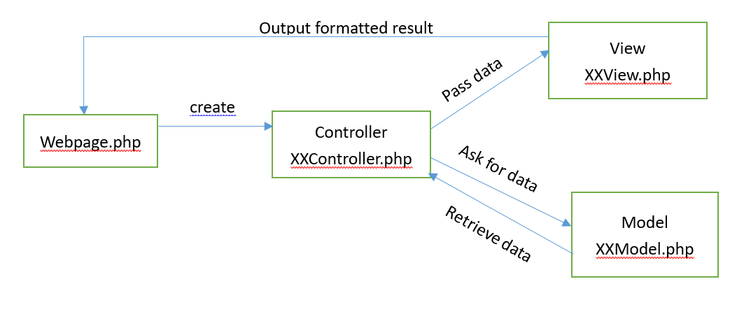

1. Question-and-Answer section

In each topic page, a question-and-answer section will be displayed. Learners can ask questions and other learners can reply them. It is similar to an online forum. All questions and answers can be seen by all users. A table will be created to store all questions and replies. Each time the user access to a Q-and-A page, the QAController object will created and will call the model QAModel to handle the data retrieve and insertion. QAView object will handle the display of the forums.

After retrieving all data and displayed, the user can add reply to some certain question or raise up question. After typing the answer and clicking the submit button, the model will use the insertion function to add data to the table.

This function can enhance the interactivity among different users and learners can discuss deeper about certain topics. Also, user can have a better understanding by teaching others.

1. Coding exercise

During the middle of learning multiple algorithms, a more complicated coding exercise can be done by the learners. Learners can submit their code and administrator can comment about their work. User can review the admin comment to have better understanding.

User codes will be stored in the database, and administrator can login their account and comments to the learners work. Learners can review the comments in their progress page.

This function is implemented as this can enhances the user the actually use the taught methods to implement in real codes. Moreover, the question will mix up different topic. The question won’t requires user to use a specific sorting algorithms and user should decide which algorithms fits the best in that scenario. This can enhance the learners to think more about the advantages and disadvantages of each algorithms.

1. Leaderboards

Leaderboards shows all user’s points and the highest points’ user will be displayed on the top of the list. It can be access in the leaderboard page. It can enhance the learning process as it gives more incentives for user to do well in the exercise. All points will be calculated by using the progress table data.

*Data Design*

1. Question-and-Answer section

A new table, qapost, are created to store all topics and answer. The attribute are the following:

|  |  |  |
| --- | --- | --- |
| Column Name | Datatype | Usage |
| Idpost(key) | INT(6) | Assign id for each post |
| type | INT(1) | Define the type of post, 0=question, 1=reply |
| userid | INT(6) | Define the user of the post |
| replyid | INT(6) | If the post is reply, it store the id of the question post which is replying to. If it is a question, store its idpost |
| content | VARCHAR(1000) | The content of the post. |
| topic | VARCHAR(45) | Topic of the post. Only question have topic. |
| Time | Timestamp | Record the time of it posted. |

1. Coding exercise

A table, codes, are created to store all coding exercise and its comments. The attribute of codes are illustrated below:

|  |  |  |
| --- | --- | --- |
| Column Name | Datatype | Usage |
| Codeid(key) | INT(6) | Assign id for each entry |
| content | VARCHAR(3000) | Store the codes |
| comment | VARCHAR(1000) | Store comment of codes |
| userid | INT(6) | Store the coder userid |
| status | INT(1) | If the code is commented, the status is 1, otherwise, 0. |
| courseid | INT(6) | Store the corresponding course id of the question. |
| managername | VARCHAR(20) | Store the corresponding manager id |

1. Leaderboards

Leaderboards will fetch data from the progress table and add the sum of all users points and list out the point accendingly. The table progress’s attribute are shown below:

|  |  |  |
| --- | --- | --- |
| Column Name | Datatype | Usage |
| Userid | INT(6) | Store the userid of certain record |
| Courseno | INT(6) | Store the corresponding course number |
| Level | INT(1) | Store the difficulties of the question |
| Progressed(key) | INT(6) | The primary key generated incrementally. |
| Mark | INT(2) | Store the marks. |

The model will sum up all the marks and the view will display the leaderboard nice and neat.

*Screen and Output Design*

1. Question-and-Answer section

The forum will be displayed in an animated collapsibles list form. User can see all the topics in the first look. User can add question on the bottom of the list. Entering the title and the content and click the submit button will get the work done.

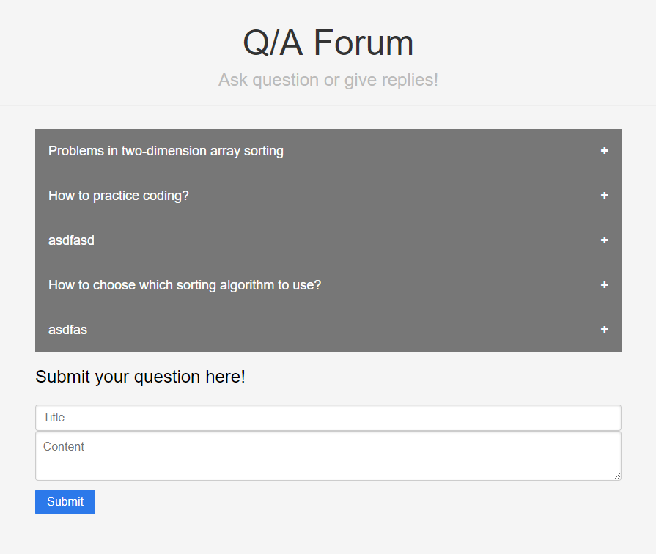

If they are interested about certain topics, they can press the topic the expand the list. The content and reply are shown in this step. User can also reply certain topics in the expanded list too.

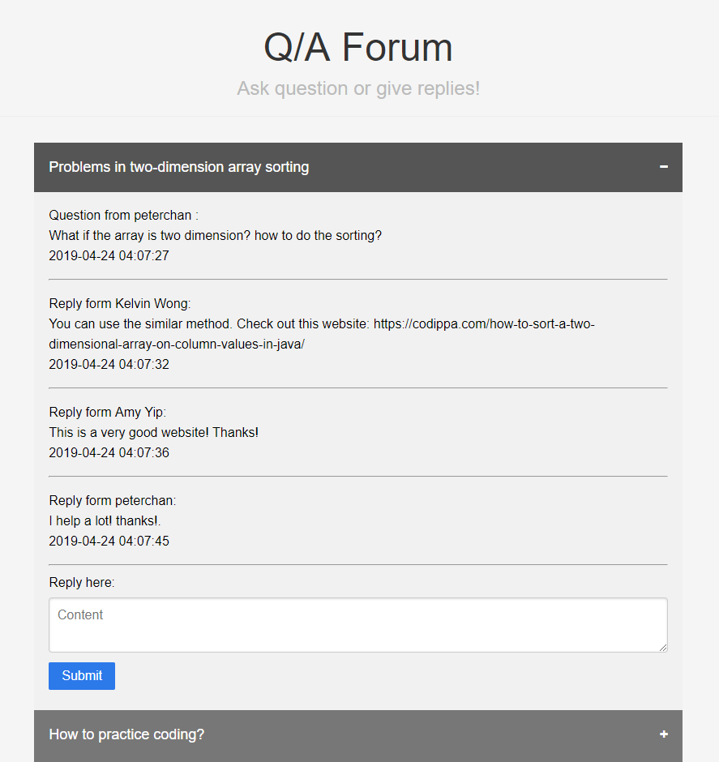

1. Coding exercise

In some learning topics, a code exercise can be seen in the bottom of the page. Clicking the button and the exercise page will be shown. User can type their code in this big textarea and submit their code. 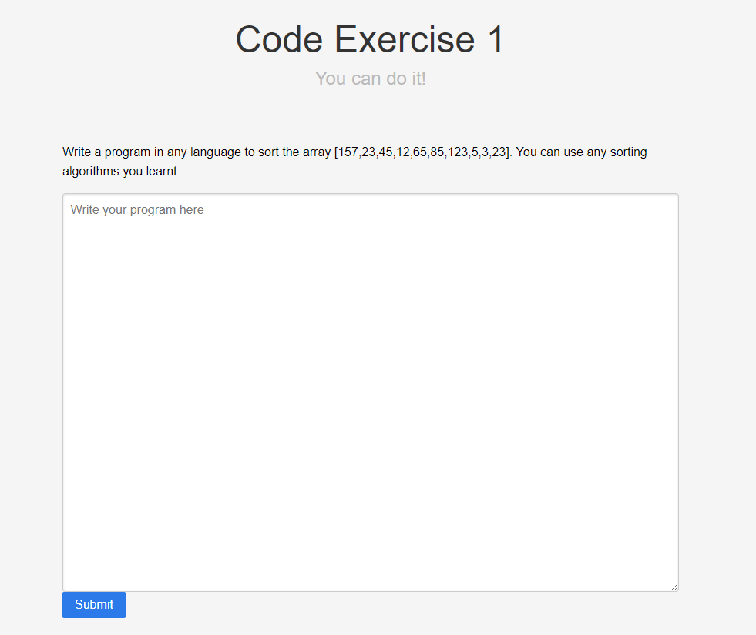

The manager can login to their account and the codes evaluation page can be access in the navigation bar. It will display in a collapsibles list form . Clicking the topic and the manager and add coment to the codes.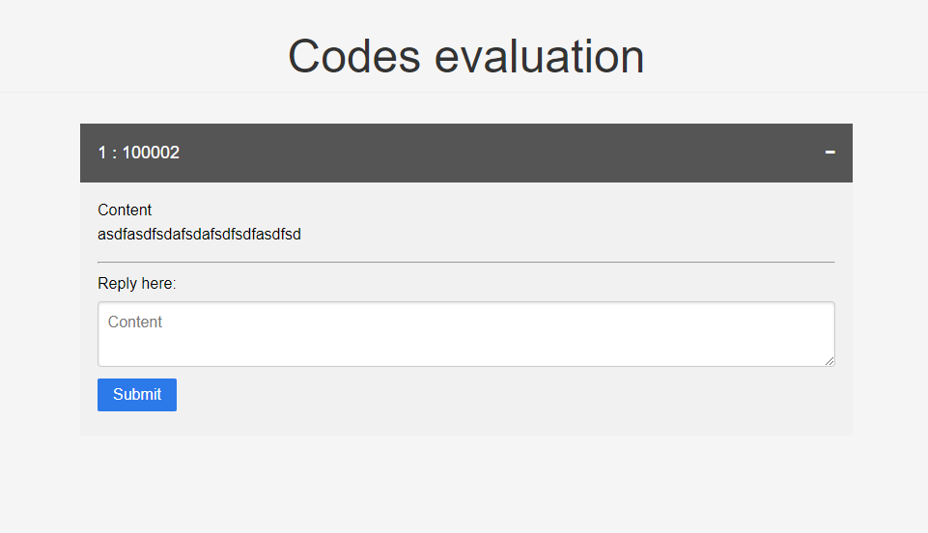

User can check their comments in the Account Information page. The display format is also using the collapsibles list form .

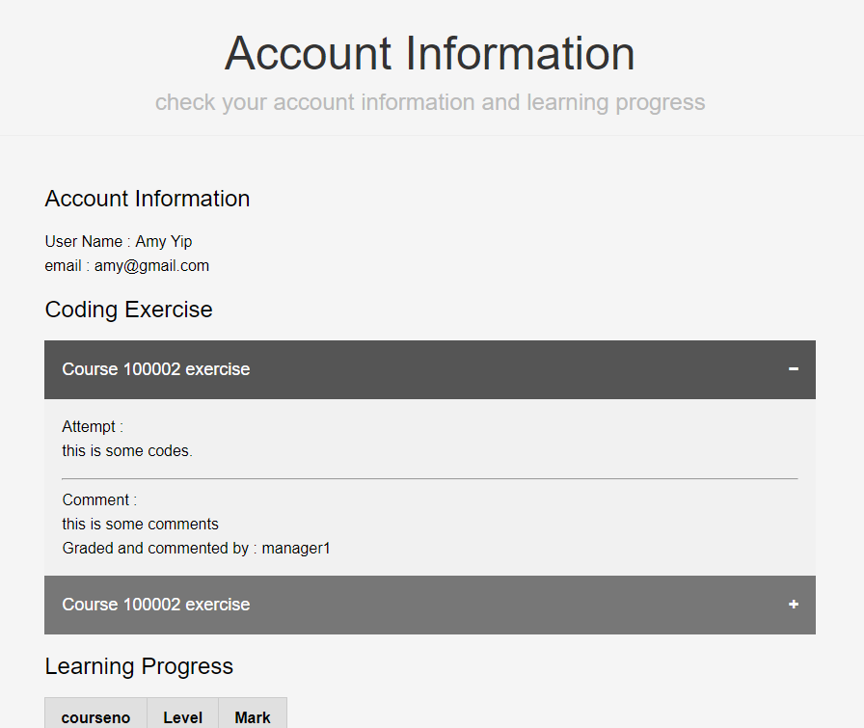

1. Leaderboards

The leaderboard can be access in the navigation bar and a simple, neat table are used to display the rank of each user.

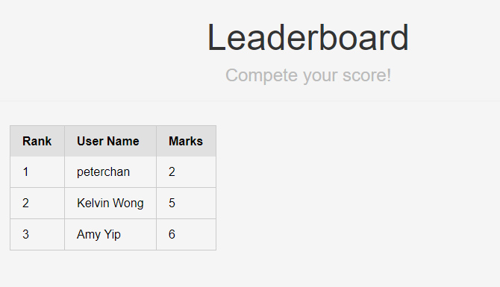

*Setup Guide*

Install Apache 24, php and Mysql workbench as the lab exercise shown, password for localhost database is 12345678. 5 tables should be created:

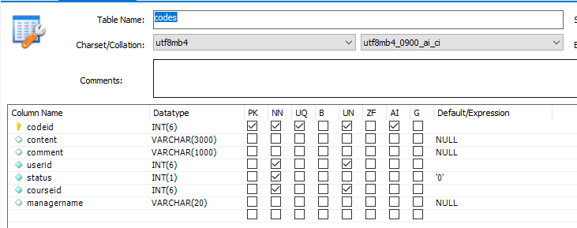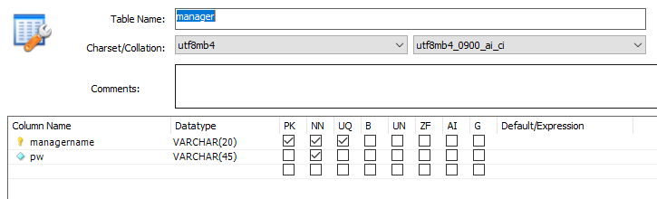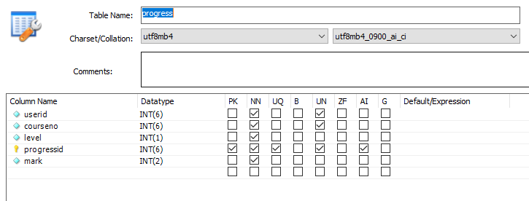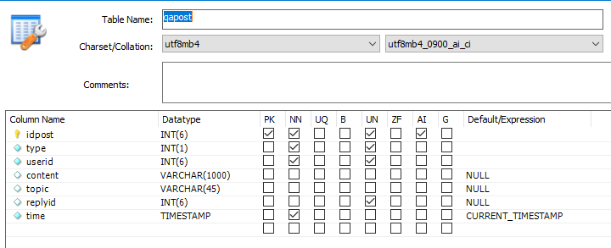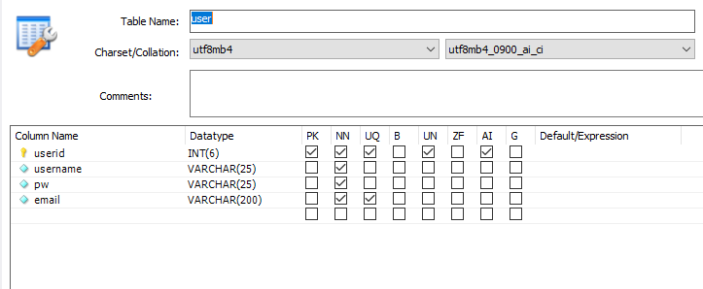

*Bibliography*

W3schools. (n.d.). Retrieved from <https://www.w3schools.com/>

Hypertext Preprocessor. (n.d.). Retrieved from <https://www.php.net/>

Tutorialspoint.com. (n.d.). Design Patterns MVC Pattern. Retrieved from https://www.tutorialspoint.com/design_pattern/mvc_pattern.htm